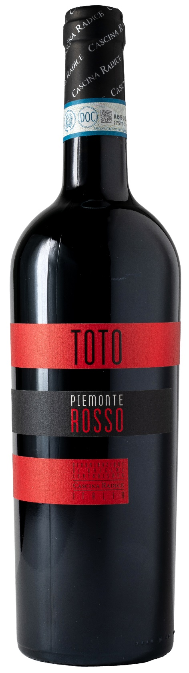
PIEMONTE ROSSO DOC – TOTO

Grape: Barbera, Cabernet Sauvignon, Merlot
Alc. Vol.%: 13,5
Vintage: 2023
Residual sugar g/l: 6,5
Total acidity g/l: 5,4
Region: Piedmont
Production zone: Vineyards in the province of Asti
Capacity: 750ml

CHARACTERISTICS

Vinification: Classical peel maceration of 10 days in steel tanks. Fermentation at a controlled temperature
Aging: 8-12 months in steel tanks
Yield per ha: 11000kg
Soil composition: Clayey marl
Colour: Strong red with purple reflections
Bouquet: Rich, fruity and spicy
Flavour: Dry, complex and full-bodied

SERVING SUGGESTIONS

Best enjoyed with substantial starters, meat and pasta dishes.
Serving temperature 16-18 °C
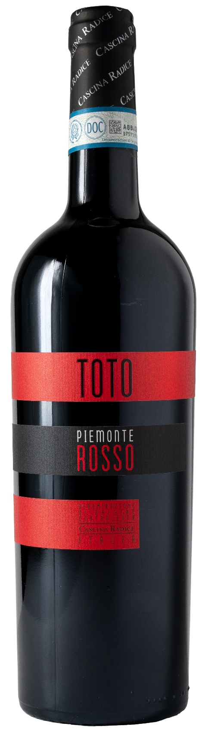
TECHNICAL INFORMATION / PALLETIZING

Size 750ml:
Article Nr. V02004A
GTIN-13 bottle 8017868003717
GTIN-13 carton 8017868003908
Closure Cork
Bottles / carton 6 bottles
Pallet size 80x120cm
Cartons/layer 21
Cartons/pallet 105
Kg/carton 8,1
Kg/pallet 870

Contains sulphites
GMO Free
Revisione 01. 21.12.2023

